[Reboot your work](https://www.youtube.com/channel/UCb_s0ySmdX17oZpcIpQrrzw)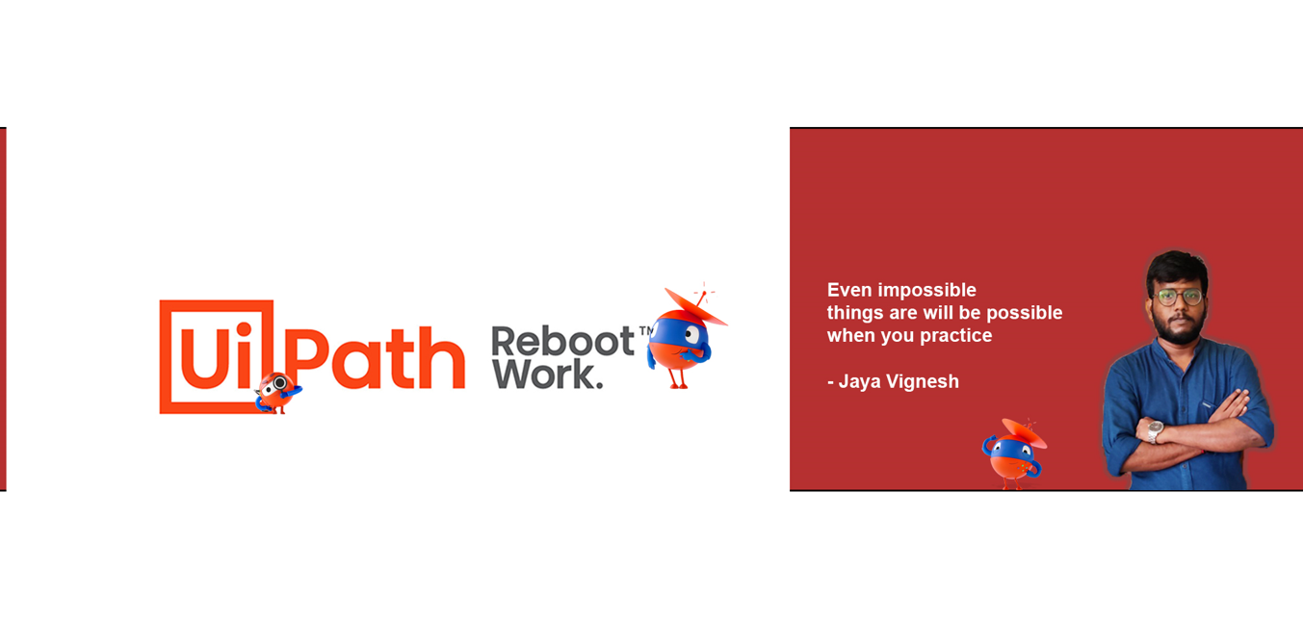

Myself Vignesh, Our channel will help you to learn Uipath for beginners & improve your developing skills in RPA- Uipath and also take you into new things which are in Market. You can start learning Uipath step by step from my channel and also, please post to your questions in comments which helps me to create Q&A Playlist. #uipathtraining #uipathautomation #uipathdeveloper